

My name is Lisa Cross I have 20 years’ experience of working therapeutically with children, young people and their families. I am a Certified Play Therapist



I am also a dual registered nurse with qualifications in both Learning Disability and Mental Health Nursing. In conjunction with this I have a specialist qualification in child and adolescent mental health

I am registered with the PTUK
(Play Therapy United Kingdom) & NMC
(Nursing Midwifery Council)
Contact me on 07769331417,
by Email – lisaatstardusttherapy@gmail.com
or through Web site https://www.stardusttherapy.com


Helping Children and families Achieve true Potential



Play Therapy
Leaflet


Play Therapy has been proven to be a successful therapeutic approach to working with children and young people who through their trauma, disability or life experience may be displaying distress in various ways. Which in turn adversely affects their educational success, friendships, family and other people in their lives.

Communication through play comes naturally to most children. Given the structured environment with play therapist they can play out their accumulated feelings of tension, frustration, insecurity, aggression, fear, confusion and bewilderment. By bringing these out in the open the children / young people will be able make sense of them and become better able to manage them, in a more appropriate way.
The play therapist achieves this by accepting the child no matter what they bring to the session; in doing so this allows the child / young person to:

- Explore their world in a safe environment
- Make sense of the painful experiences they have sustained, experiences which they may not be able to recall in words
- Understand, name and regulate their feelings
- Learn how to manage boundaries and resolve problems effectively in the session. This leads to the child being able to problem solve elsewhere in their life
- Although the session is undirected it has its own boundaries, which the child has to learn how to accept and deal with the feelings surrounding this. This helps them to manage the boundaries that are placed on us throughout life
- Learn to accept the consequences of their actions
- Learn how to relate to the therapist without being helped which in turn helps them to be in control of their own destiny
- Learn how to play both on their own and with others which in turn helps them better relate to adults and children in their wider world
- Build their internal ability to self-praise, approve of themselves, gain inner respect and build self-esteem.
- If play does not come naturally they can learn to play, a vital tool for life – play builds the brain pathways needed in education

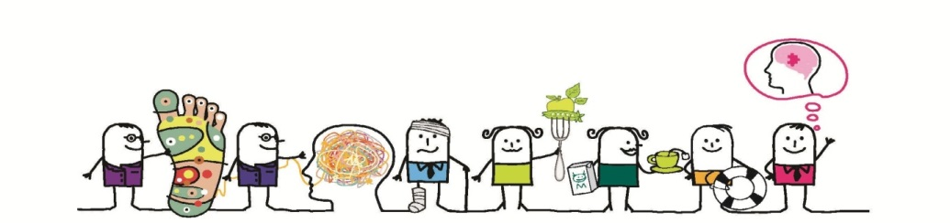
Why Play based intervention?
- Play Therapy is a well-established discipline based upon a number of psychological theories. Research, both qualitative and quantitative, shows that it is highly effective at helping children who have suffered multiple traumas abuse and or neglect (Jess Thomas, 2011 - 2015)
- Recent research by PTUK suggests that 75% - 83% of the children referred will show a positive change (Jess Thomas, 2011-2015)
How many sessions will a child need?
- The number of sessions required is roughly determined by using the Strengths and Difficulties questionnaire. This is completed by someone who knows the child very well such as the teacher or parent the score is then assessed.
- Approximately S & D scores of 15 – 17 equate 15 sessions; 17 – 19 equates 20 sessions and 18 – 21 equates 25 sessions.
What’s the length of the session?
- The session normally lasts between 45 mins depending on the cognitive / developmental stage of the child. (45 mins is the average).
It is important that the child is
- Seen at the same time, in the same room, with the same toys and on the same day each week.
Will the child have to miss school?
- The child may miss some school however if they are able to deal with their distress then there should be an increase in the ability to succeed academically (Kestly, 2014).
How will we assess if the child needs are being met?
- The intervention will be regularly reviewed with yourself and any others involved in your child’s care.
How will I know if the therapy is working?
- We will complete the strengths and difficulties questionnaire again and gain feedback regarding differences noted by you and other people in the child's care network and more

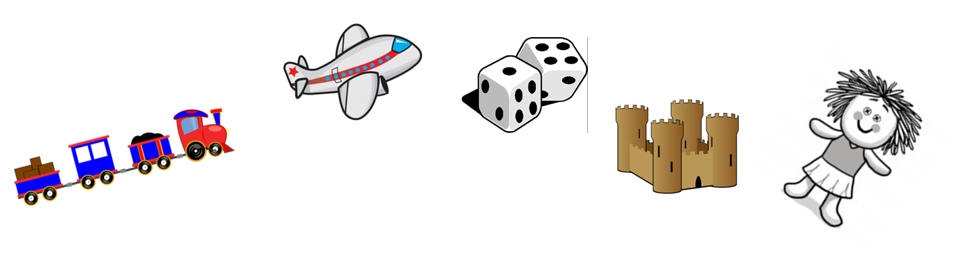

- Importantly …“YOUR CHILD WILL NOTICE”

